**Android Blood Bank**



Session: 2016 – 2020

**Submitted by:**

2016-CS-106

2016-CS-172

**Supervised by:**

Miss Hina Khalid

Department of Computer Science and Engineering

**University of Engineering and Technology**

**Lahore Pakistan**

Table of Contents

Table of Figures 3

1User Interfaces 4

1.1 Login Activity 4

1.2 Registration Activity 5

1.3 Authentications Details Activity 6

1.3.1 Medical History Activity 7

1.4 Home Activity 8

1.5 Search Donor Activity 9

1.6 Donor’s Details Activity 10

1.7 Donor’s Medical History Activity. 11

1.8 Search Acceptor Activity 12

1.9 Acceptor’s Details Activity 13

1.10 Acceptor’s Medical History Activity 14

1.11 Blood Bank Activity 15

1.12 Profile Activity 16

2 Entity Relation Diagram 18

# Table of Figures

Figure 1 Login Activity 3

Figure 2 Registration Activity 4

Figure 3 Authentication Detail Activity 5

Figure 4 Medical History 6

Figure 5Home Page 7

Figure 6 Search Donor 8

Figure 7 Donor Profile 9

Figure 8 Donor's Medical History 10

Figure 9 Search Acceptor 11

Figure 10 Acceptor's Profile 12

Figure 11 Acceptor's Medical History 13

Figure 12 Blood Bank 14

Figure 13 Profile Activity 15

Figure 14 ERD 16

# 1User Interfaces

## Login Activity

In this Activity

* User can Login by providing his Registered Username and password.
* User can opt to register.

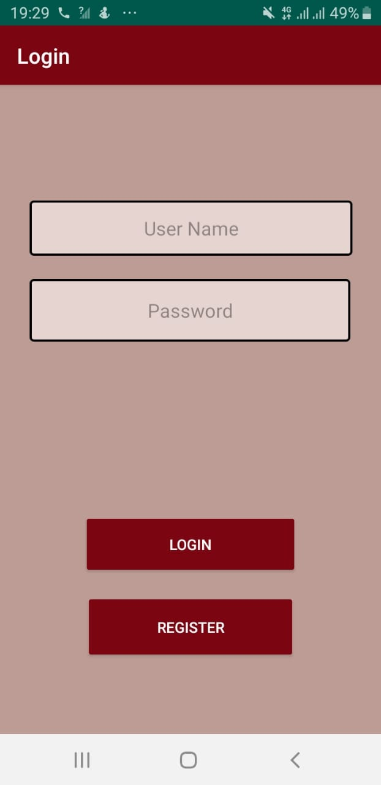

Figure 1 Login Activity

## 1.2 Registration Activity

This activity will appear when the user will click the register button on the Login Activity. In this Activity

* User will provide his name.
* User will provide his email.
* User will provide his Contact number.
* User will provide his address and city.
* User will provide his Gender.
* User can opt to Authenticate details.

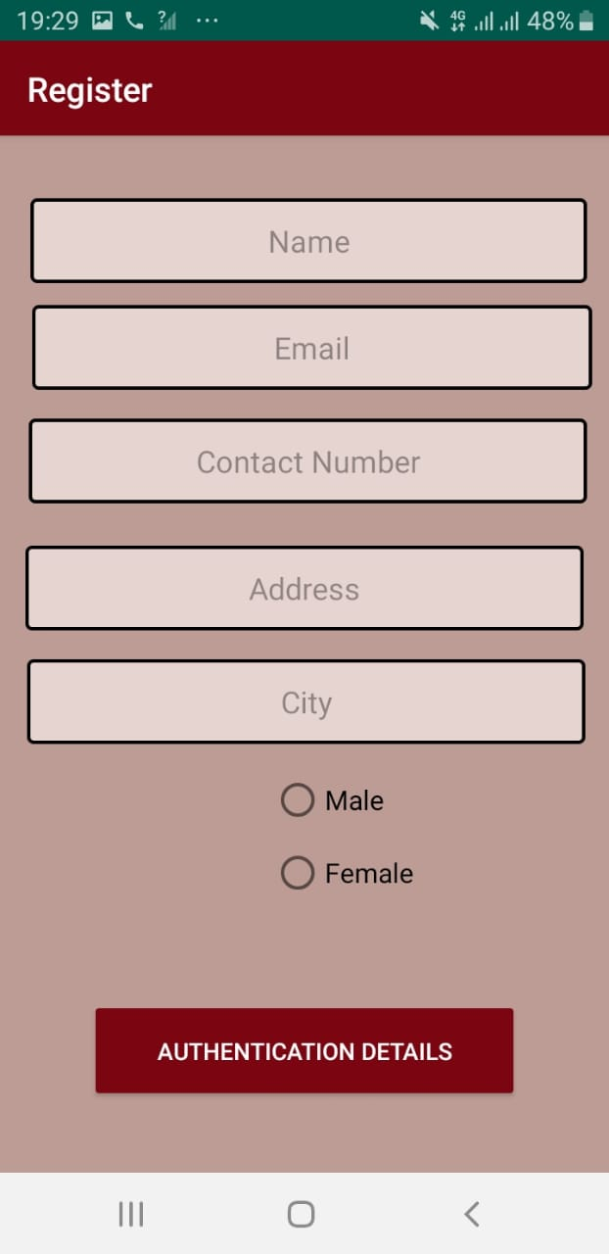

Figure 2 Registration Activity

## Authentications Details Activity

This screen will appear when the user will click the authenticate detail button on register Activity. In this Activity

* User will provide his username.
* User will provide password.
* User will provide his Profile pic.
* User will select his Blood Group.
* User will select whether he is a donor or not. If he isn’t he will be treated as acceptor.
* User can opt to Register and will be taken to Login Screen after clicking the Register Button.

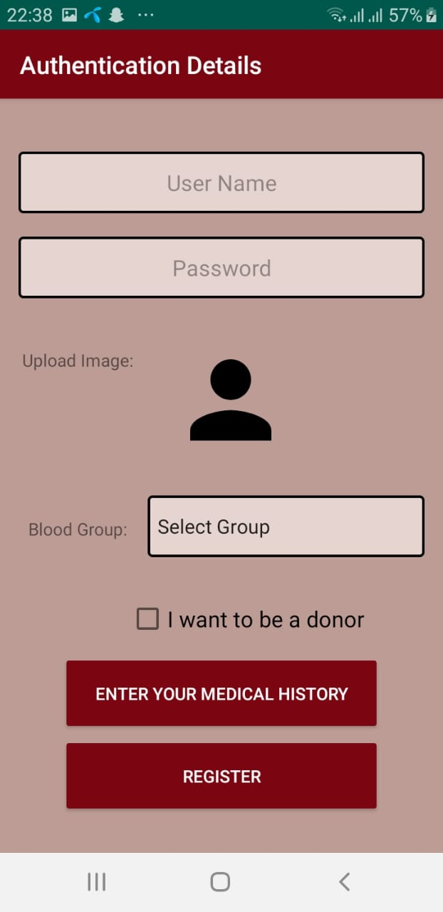

Figure 3 Authentication Detail Activity

### Medical History Activity

This screen will appear when the User will select the Medical History button on the Authentication Details Activity. In this Activity

* User will provide his allergies (if any).
* User will provide his Medical condition.
* User will provide diseases he is suffering from (if any).
* User will provide other medical details (if he wants to).

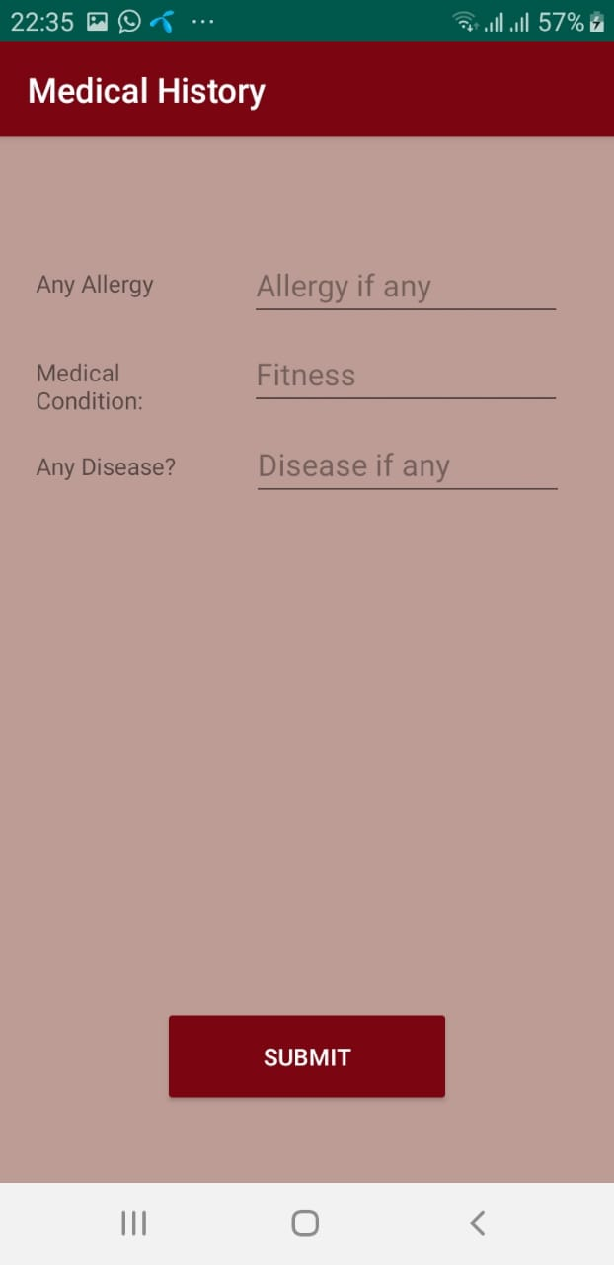

Figure 4 Medical History

## Home Activity

This screen will appear when the User will login by providing his registered Username and password. In this Activity

* User can search a donor.
* User can search an acceptor
* User can see the blood bank details.
* User can see his Profile Details.

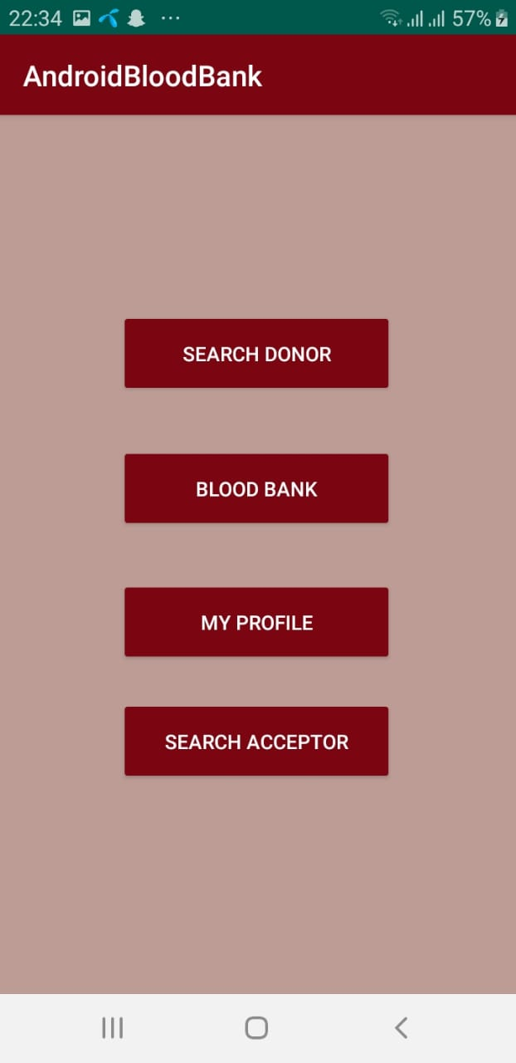

Figure 5Home Page

## Search Donor Activity

This screen will appear when the User will select Search donor option on home. In this Activity

* User can search a donor by blood Group.
* User can opt to see Donor Details.

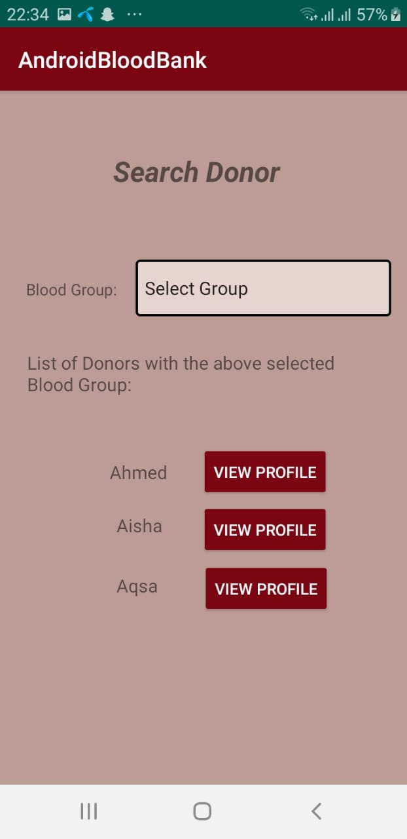

Figure 6 Search Donor

## Donor’s Details Activity

This screen will appear when the User will select to see donor’s detail option on Search Donor Activity. In this Activity

* User can see details of donor
* User can contact the donor.
* User can opt to see Donor’s Medical History.

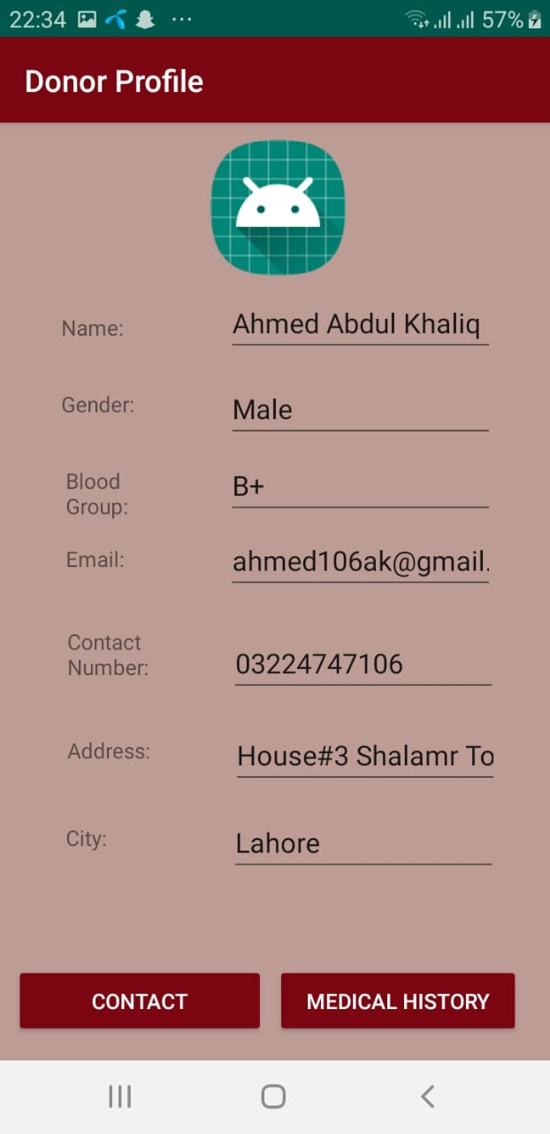

Figure 7 Donor Profile

## Donor’s Medical History Activity.

This screen will appear when the user will click Medical History Button on Donor’s Details Activity. In this Activity

* User can see the Medical history details of Donor.

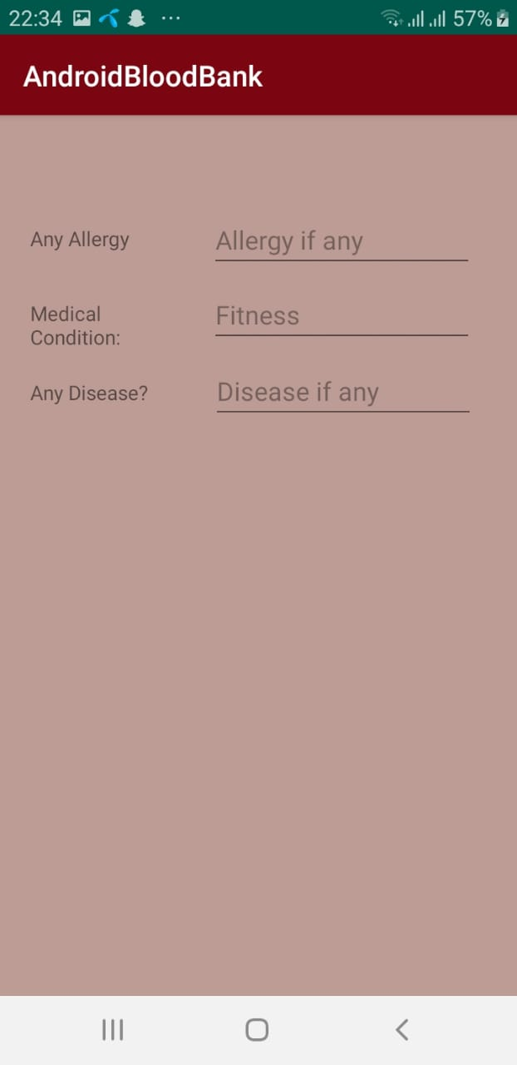

Figure 8 Donor's Medical History

## Search Acceptor Activity

This screen will appear when the User will select Search acceptor option on home. In this Activity

* User can search a acceptor by blood Group
* User can opt to see Acceptor’s Details.

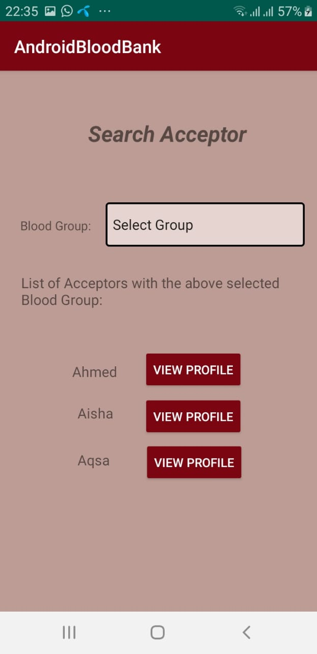

Figure 9 Search Acceptor

## Acceptor’s Details Activity

This screen will appear when the User will select to see acceptor’s detail option on Search Acceptor Activity. In this Activity

* User can see details of acceptor.
* User can contact the acceptor.
* User can opt to see Acceptor’s Medical History.

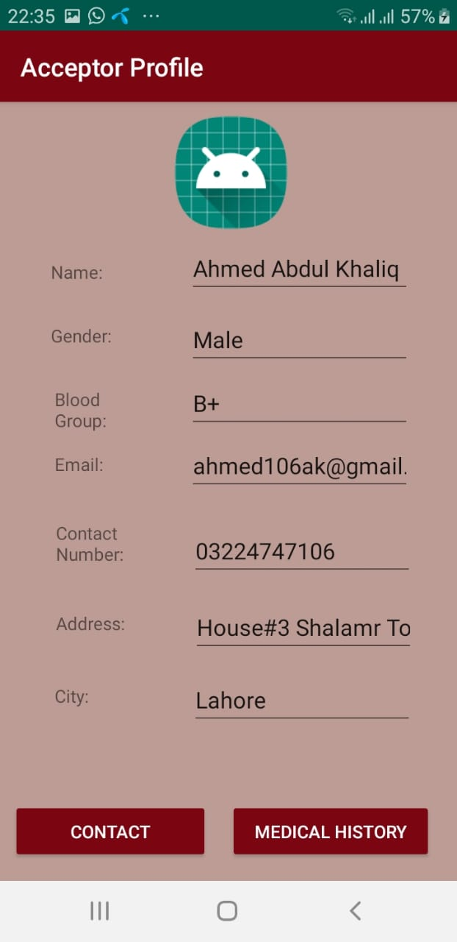

Figure 10 Acceptor's Profile

## Acceptor’s Medical History Activity

This screen will appear when the user will click Medical History Button on Acceptor’s Details Activity. In this Activity

* User can see the Medical history details of Acceptor.



Figure 11 Acceptor's Medical History

## Blood Bank Activity

This screen will appear when the user will click the Blood Bank button on the Home Activity. In this Activity

* User can see the no. of donor’s available for each blood group.

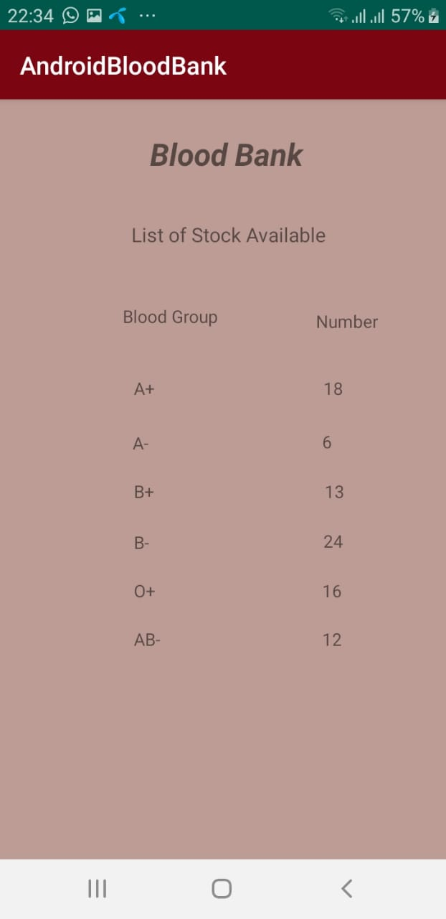

Figure 12 Blood Bank

## Profile Activity

This screen will appear when the user will click the Profile Button on the Home Activity. In this Activity

* User can see his Profile details.

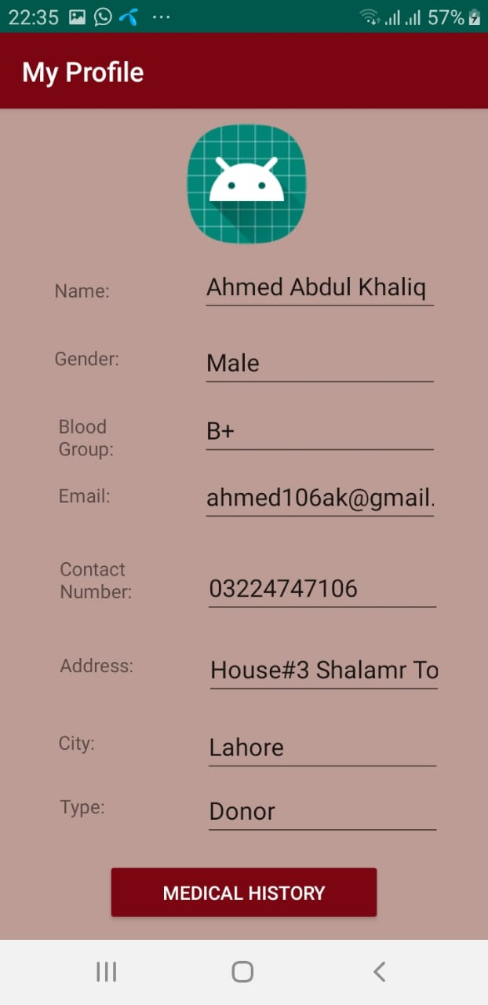

Figure 13 Profile Activity

# Entity Relation Diagram

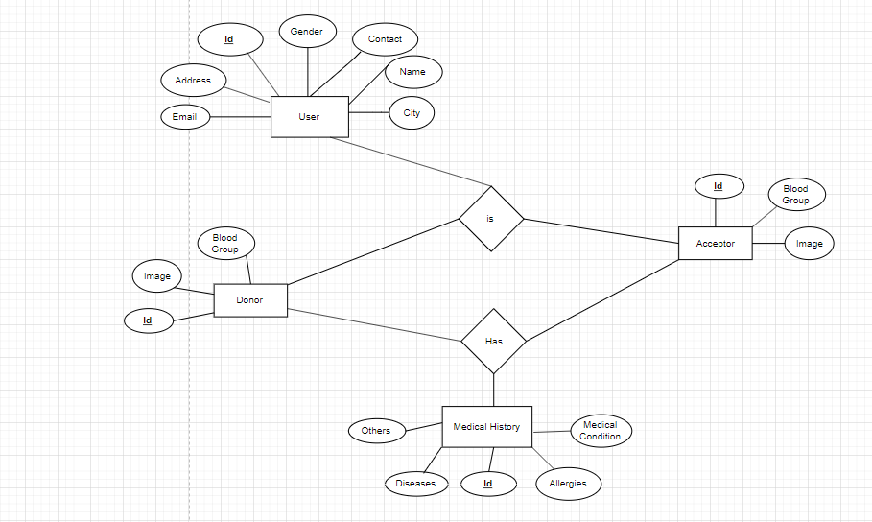

Figure 14 ERD